Practical 3
AIM: Memory analysis of malware samples using tools such as Volatility.
Malicious process analysis from: -
- Sample.vmem
- Before process analysis first we need to analyse the image profile for use imageinfo plugin
└─# python2 vol.py -f sample.vmem imageinfo

- Search for the malicious process using psscan plugin
└─# python2 vol.py -f sample.vmem --profile=WinXPSP2x86 psscan

- Identified 2 lsass running now check which is malicious by dlllist plugin
└─# python2 vol.py -f sample.vmem --profile=WinXPSP2x86 dlllist -p 1928,868

- Found malicious dll as kernel32 renamed for tricking user and system with legitimate one
└─# python2 vol.py -f sample.vmem --profile=WinXPSP2x86 dlldump -p 1928 -b 0x00870000 --dump-dir=./dumps

- Now we need to dump this dll and check with virus total

└─# python2 vol.py -f sample.vmem --profile=WinXPSP2x86 dlldump -p 1928 -b 0x00870000 --dump-dir=./dumps

- Check the dumped dll in virus total

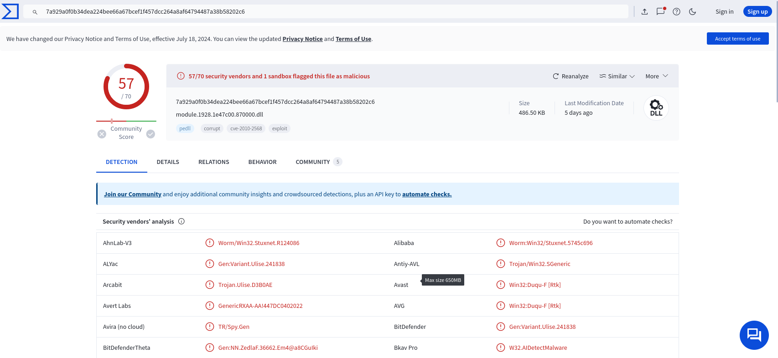

- This is the malicious dll we got from this sample as sample.vmem

